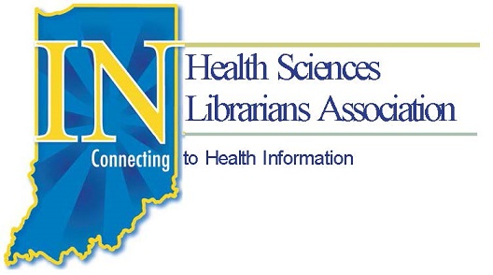
IHSLA 2016 ANNUAL MEETING

Leaping Forward

The Garrison Conference Center at Fort Harrison State Park
5830 North Post Road, Indianapolis, IN 46216
Thursday, April 14th

Registration open noon-1pm

1 - 4pm Theodore Room

Continuing Education-
Engaging Assessment to Show Value and Make Decisions: Making the Case for your Library, Lisa Hinchliffe - As libraries are increasingly asked to demonstrate their value and the contributions they make to their institutions, library staff need efficient and effective strategies for assessment. Best practice in assessment means embedding assessment into the library's practices on a continuous basis rather than treating it as a separate and additional task. The workshop will present an integrated and systematic approach to developing and assessing library activities that includes identifying impact outcomes and aligned activities, establishing criteria, collecting and analyzing data and evidence, and using the results for improvement and telling the story of the library's impact. Participants will have the opportunity to practice using the tools and techniques presented.

CE Contact Hours: 3 • Face to Face about Assessment/Evaluation, Leadership, Management, Outreach/Advocacy ​

4:30-5:30 IHSLA Executive Board Meeting
President’s Suite - Everyone is welcome to attend!

5:30 ish Dinner on your own or with an informal group

Thank you to our 2016 Sponsors!

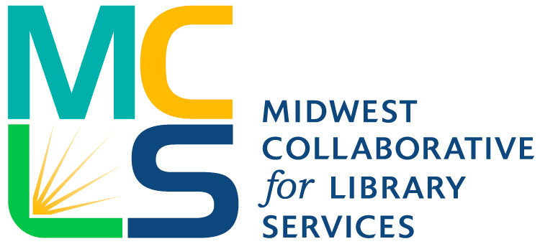

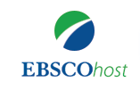
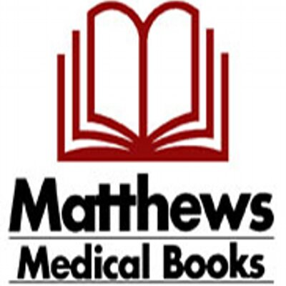
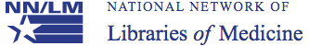

UIC

Friday, April 15th - Roosevelt Ballroom

7:30- noon | Registration Open
7:30am-8:45am | Breakfast with Exhibitors
8:45am-9:00am | Welcome and Introductions
9:00am-10:00am | 3D Printing!  Jennifer Herron, Emerging Technologies Librarian, Ruth Lilly Medical Library, IU School of Medicine
10:00am-10:30am | Break with Exhibitors & Poster Session
10:30am-11:15am | Academic/Hospital Breakouts
11:15am-12:00pm | De-stressing Apps  Jennifer Herron, Emerging Technologies Librarian, Ruth Lilly Medical Library, IU School of Medicine
12:00pm-1:30pm | Lunch with Exhibitors  Updates  - GMR Carol Bean, Greater Midwest Region, National Network of Libraries of Medicine  - Medical Library Association Amy Blevins, Ruth Lilly Medical Library  - Midwest Chapter/MLA Beth Whipple, Ruth Lilly Medical Library  - Midwest Collaborative for Library Services, Nancy Kirkpatrick  - Indiana Library Federation, Tisa Davis
1:30pm-2:30pm | Crowdsourced Art  Kacy Allgood, Research & Community Outreach Librarian, Ruth Lilly Medical Library, IU School of Medicine
2:30pm-3:00pm | Business Meeting, Election of New Officers, Presentation of the Ovation Award
3pm | Adjournment

Poster
Coming to a Library Near You: How Librarians Brought an NLM Exhibit to their Institutions
Carolyn Martin, MLS, AHIP, Caryl Wyatt, MLA, Chris Bishop, MLS

